CAS CS 585 Image and Video Computing - Fall 2018

Project Proposals P2

Due electronically before class on November 20, 2018.

* Create a web page for your project that lists the team members, has a TITLE for your project, and a project problem definition.
* Show images or link videos that you will use as your input.

*Link both lab cam and Jason’s recording*

Screenshot:

Lab cam:

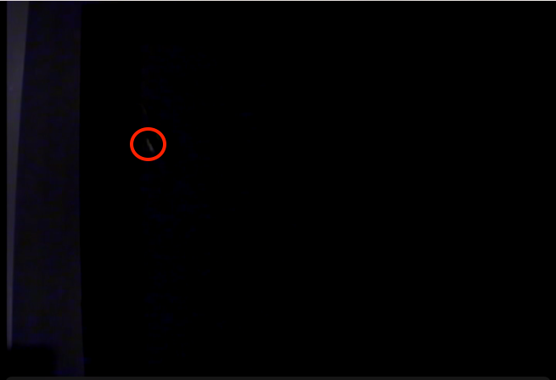

The rat (inside red circle) from lab cam input is almost indistinguishable to human eyes. However this recording setting is not exactly the same as usual lab experiment setting.

Jason’s recording:

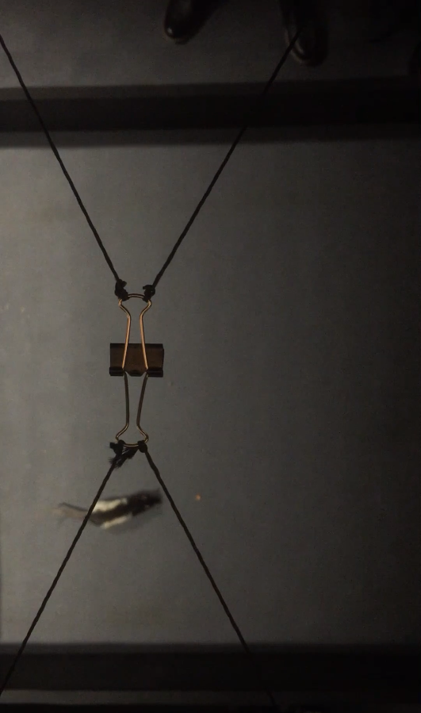

The iPhone footage is much clearer with many details. For example a small piece of food can be seen clearly in front of the rat.

* Show the desired results of your project, for example, manually marked-up images/videos, or the kind of numerical output you want.

The desired result should be a rats/mice tracking system, that works in desired lighting conditions, and is able to track the animals consistently. Depend on the scientists’ requirements, we can output a trail on the live video, and also output an array of coordinates along the recording. We are also thinking of integrating the readings from the equipment that the neuroscientists are tracking and present the readings along with our tracking for easier understanding and comparison. The project deliverable should be a script or a software with an UI.

* Do some background research about your problem. Have other people tried to solve this problem? Find at least computer vision paper in the literature or identify an algorithm discussed in class or described in a textbook chapter that might be helpful in solving your problem.

*TRY TO ADD MORE HERE*

Most softwares found are proprietary.

Tracking methods including computer vision methods, manual tracking and recording from video, and RFID(radio frequency identification) implants[https://www.ncbi.nlm.nih.gov/pubmed/25141063 *please add reference*].

For this problem we are thinking two tracking methods: Kalman Filter or Alpha-Beta filter. Data association would not be too big of a problem because there would not be too objects of interest being tracked. In the event of collision of two objects, some hard-coded rules will be applied.

* Add whatever else you have done so far for your project.

Some results from experiment:

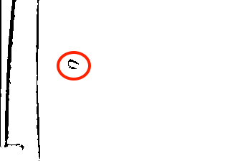

Preprocessing using lab cam footage

The silhouette of the main body of the rat is visible, and it’s visible across frames. However since the lighting is not consistent and it’s brighter on the left than on the right, when the rat moves to the right of the frame there is no trackable color difference across all 3 channels from the lab cam recording.

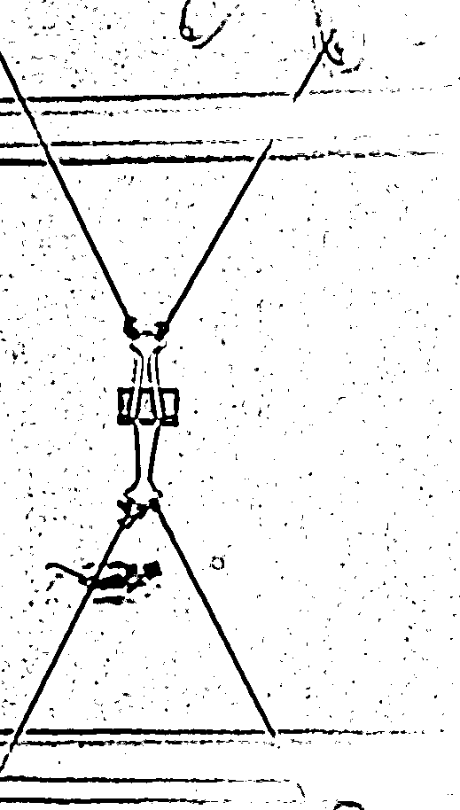

Preprocessing using iPhone camera

The rat and a piece of food(the little circle in front of the rat) is clearly visible and it’s possible to determine the rat’s orientation by locating its tail. The stationary wires and the clip can be removed using background differencing. The rat and the food piece are clearly visible throughout the video.

What next:

Acquire new footages in exactly the settings the scientist perform experiments on, recorded with both lab cam and iPhone camera. If the lab cam footage works, we will go on from there and implement the tracking system. If not, we need to switch to the iPhone footage. We will also record from different angles and try to implement some useful functionalities related to absolute orientation.

* To make sure that each student in the class is engaged in the project and has documentatio for that, each of you should gsubmit a link to your own personal project web page. The web pages of the students in one team can be basically the same, except that at the top, you can should have your name first and then list your team members. This way, you can use the web page for own job or grad school applications.